History of the Church

**1950**

In the early 1950’s, Mass for the Kerikeri Catholics was a rare event. Father Purcel from Kaikohe would meet with his congregation at the Waipapa Hall, once a month. Later in the 1950’s, Fr. Frank Scott joined Fr. Purcel and he became a regular visitor to the area. Mass was celebrated fortnightly at the Women’s Institute Hall.

**1960**

In the 1960’s Kerikeri was transferred to the Moerewa Parish. Fr. Mehrtens was the parish priest, later replaced by Fr. Nealan. Mass was fortnightly and the Kerikeri parishioners travelled to Moerewa.

Amongst the small congregation, about 8 families at this time, we had a parishioner, Philip Padbury, he welcomed all new comers. He prayed daily that our numbers would increase, that we would have our own church, and the Blessed Sacrament would dwell in Kerikeri. In 1963 Philip and Helen Padbury donated the land to the Bishop of Auckland on which our church and Children Catholic Doctrine (CCD) classroom stand today.

**1970**

In 1971, Waitaruke Parish adopted the Kerikeri churchgoers and Fr. Cushlow was the Parish Priest. After a time of Mass held in halls, homes and gardens, Fr. Cushlow approached the Anglican Community about the availability of St. James. They readily accepted us. It was a wonderful arrangement, we had Mass every Sunday.

We shared Fr. Cushlow’s enthusiasm for the mission station at Waitaruke. The Marist Sisters were teaching at the school, and running a hostel for over 80 boarders. Until the school was fully integrated, the hostel closed, and the teaching sisters dispersed, Kerikeri had a very close association with Waitaruke. Wym Hendrikse and Peter Westend gave valuable assistance with the farm and later, Moss Pepper and Fred Hunt. Orchardists were generous with fruit and vegetables. Labour weekend was the time of the Annual Fair, always generously supported by Kerikeri.

Fr. Cushlow was elected superior of Mill Hill Fathers in 1974, and moved to Auckland. Fr. Laidler was appointed his successor.

**1980**

Gradually, our numbers increased with the arrival of families, which included the Hunts, Peppers, Honnis, Shaws, Douglas, Stewart, O’Brien, Bests, Joseys, McNeils, Blakelys, Penmans to name but some. Our congregation was outgrowing. St James in 1982 we had about 100 parishioners many of whom were children. Meetings were held to consider the possibility of building a Church, designs were discussed, plans drawn, builders consulted. Some serious fund raising was required, cake stalls no longer an option – a committee was formed, and it was decided, that the personal approach was the way to go. When a reasonable amount was banked and a reasonable amount pledged, it was time, to call on the Chancellor of the Exchequer, Monsignor Wright, and get his permission to build. Lew Clare and I were asked to take the necessary documents to Auckland and plead our case. Fortunately we took our trusty friend Father Cushlow along with us – by now he was a member of the College of Consultors, so held rank. After much persuasion the Monsignor finally relented and approval was granted. However, no finance would be available from the diocese.

The Section was cleared by Philip Padbury, Bruce Douglas, Lew Clare and Wym Hendrikse. The chainsaws were working now non-stop, the timber sold as firewood. An architect and structural engineer engaged and final plans and specifications drawn up.

Church Building commenced at the end of 1982. We had the services of a very generous builder, and his firm absorbed much of the cost. Brian Reeve was appointed chief painter and finisher, he was ably assisted by a couple of ladies and Wym. Greg Long made the Cross and shelves, wood turned the candlesticks and stands. Almost everything in the church was donated – carpet, a gift from the Mill Hill Fathers, pews and chairs were from the members of the congregation and there were generous donors who donated: Altar and Tabernacle, Monstrance, Sacred Vessels, Lectern, Lectionaries, Organ, Vestments, Altar Linens, a sound system and Processional Cross and Candle Holders.

Monsignor Wright was so impressed by our effort, he donated the Stations of the Cross, Benediction Candelabra, and baptismal font which all required refurbishment.

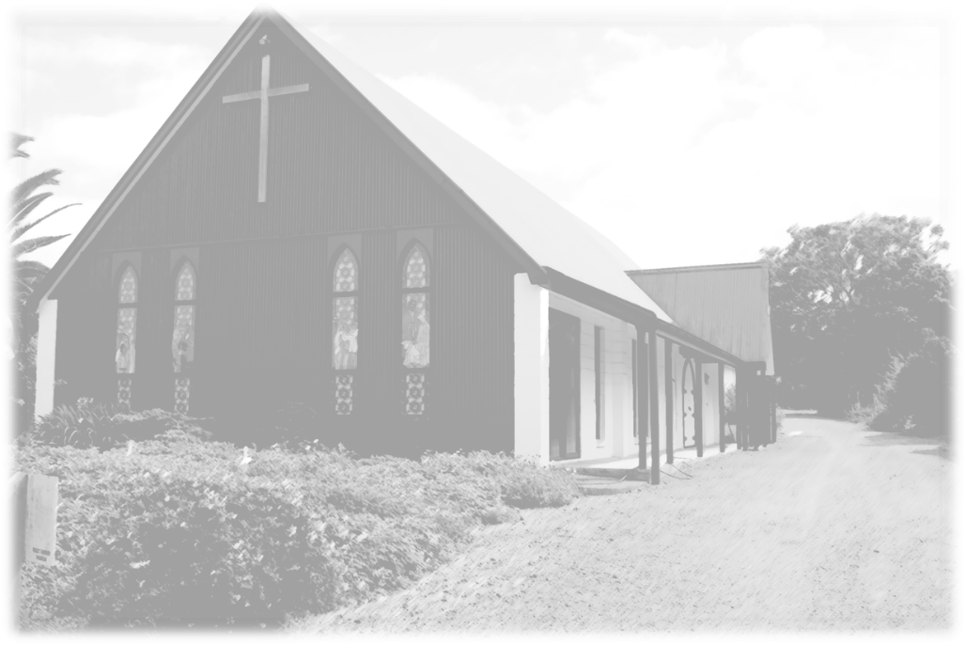

**Naming the Church**

Our Church was consecrated, blessed and dedicated to the Holy Family, on 26th June 1983 by Bishop Rodgers. Clergy from surrounding parishes attended, local representatives and friends who had assisted in our endeavours were invited plus our own parishioners. This was followed by a reception at the Returned Services Association (R.S.A.) Clubrooms located in Hone Heke Road at that time.

Later in 1983, we were offered the section adjoining our church grounds, once more we had to negotiate with Monsignor Wright with its purchase. He finally agreed to buy it on our behalf all we had to do was pay for it, and pay the accrued interest. Fundraising was the order of the day.

**Holy Family Church become a Parish**

Bishop Denis Browne was appointed bishop of the Auckland Diocese in 1984. In 1985, he informed us that Kerikeri was to be a Parish in its own right and that Father Kevin Fitzgerald was to be our Parish Priest. Sadly, we said goodbye to Fr. Laidler, and our connection with the Mill Hill Fathers, who had cared for our people for so long. We welcomed Fr. Kevin in February 1986. Unfortunately he was not with us long, he left in November. Until Father Liam Shanaghan took up his appointment in 1987, we were supplied by Fr. McFall, and Fr. Chris Duggan. Fr. Shanaghan’s stay with us was curtailed, our finances were depleted, we could not support a resident priest. Fr. Laidler was asked by Bishop Browne to return as our priest and remained so until his death 9th February 1996 – God grant him eternal peace. He was a faithful minister of the Word of God and Sacraments.

**1990**

Whilst Fr. Laidler was on sabbatical in 1989, Fr. Cushlow supplied for him, Fr. Cushlow told us it was about time we cleared our debt, and “to get cracking.” Out came the chequebooks again, this time we over subscribed by a few thousand dollars. Now was the time for us to do some extension, have a meeting room, kitchen, toilets and a proper sacristy and reconciliation room. More money was raised. Interest Free loans negotiated. One parishioner inquired how much more was required, and when told $15,000.00 wrote out a cheque there and then, the extension was completed early 1990.

In 1991, the Marist Sisters came to Kerikeri, their convent was in Jacaranda Place. They were a welcome presence in our community, Sister Clement, a much loved familiar figure was with us for nearly 15 years. In fact, she has never really left us.

By 1992 the Interest Free loans were repaid and we were totally debt free. Our Church, a section and an extension. All in 10 years. We give thanks for our benefactors and donors for their unselfish generosity, many of whom have gone to their reward.

**2000**

Father Tony Brown was the next appointed parish priest. He arrived complete with Whanau and guitar. His first official duty was Fr. Laidler’s funeral. Fr. Tony was with us for five years.

In 2001 we welcomed the Missionary Society of the Philippines (M.S.P.) Priests – Father Rey Retalago and Fr. Gerome Fernandez. How blessed we were to have them with us for over three years.

By 2004 big changes were taking place in the North. The Marist Fathers had agreed to minister to the Bay of Islands, Kerikeri, Waitaruke, Kaikohe and Rawene. Fr. Brian Prendeville and Fr. Arthur Toothil were already in the area and headed the team. They were joined by Fr. Bernard Carney and Fr. Michael O’Donnell and Brother Denis. Okaihau was chosen as the place for headquarters. Once they were established and their new way of ministry was in progress, Fr. Brian moved on to missionary work in Australia, Fr. O’Donnell and Fr. Carney moved to other Parishes and Fr. Peter MacDermott then joined the team.

How the times have changed! C.C.D. was no longer taught by correspondence, dedicated parents have taken up the challenge and prepared the children for the Sacraments of the Eucharist, Confirmation and Reconciliation. Our young people are participating in Sunday Liturgy and taking their place in our ever changing church. The weekly newsletter has moved with the times also, from gestetner production to computerisation. Parish Councils were elected, we have moved from a building and maintenance committee to a finance committee. A Care Group was established, Catholic Women’s League, St. Vincent De Paul, Daily Rosary, Marian Mothers, Dove, Joshua, Praise and Worship Group and Youth group formed. Walk by faith, Alpha, Renew, Catholics Returning Home, Bible Study, Retreats and Liturgy Programmes conducted to name just some of the activities that have been initiated over the years.

To the clergy past and present, we owe a special debt. They have consecrated their lives to God for our spiritual well being, may we in return be worthy of their sacrifice.

Finally a tribute to Wym Hendrikse, Brian Reeve and Jane Berry who have maintained our building and grounds over the past 25 years. Jane the gardens and all the jobs that we take for granted, your efforts are appreciated.

Compiled for our Silver Jubilee June 2008

***Maureen Clare***